**Chapter**

**1**

# The Exceptional Manager:

# What You Do, How You Do It

**CHAPTER CONTENTS**

Major Questions the Student Should Be Able to Answer 2

Mapping the Class: Chapter Outline 3

Overview of the Chapter 5

Classroom Outline 7

Challenge: Major Questions 36

Management in Action 38

Legal/Ethical Challenge 40

Group Exercise 42

Manager’s Hot Seat 44

**MAJOR QUESTIONS THE STUDENT SHOULD BE ABLE TO ANSWER**

# Management: What It Is, What Its Benefits Are

# MAJOR QUESTION: What are the rewards of being an exceptional manager?

# What Managers Do: The Four Principal Functions

# MAJOR QUESTION: What would I actually do—that is, what would be my four principal functions—as a manager?

# Seven Challenges to Being an Exceptional Manager

# MAJOR QUESTION: Challenges can make one feel alive. What are seven challenges I could look forward to as a manager?

# Pyramid Power: Levels and Areas of Management

# MAJOR QUESTION: What are the levels and areas of management I need to know to move up, down, and sideways?

# The Skills Exceptional Managers Need

# MAJOR QUESTION: To be an exceptional manager, what roles must I play successfully?

# Roles Managers Must Play Successfully

# MAJOR QUESTION: To be an exceptional manager, what roles must I play successfully?

# The Link between Entrepreneurship & Management

# MAJOR QUESTION: Do I have what it takes to be an entrepreneur?



**1.1 Management: What It Is, What Its Benefits Are**

* The Rise of the Die Maker’s Daughter
* Key to Career Growth: “Doing Things I’ve Never Done Before”
* The Art of Management Defined
* Why Organizations Value Managers: The Multiplier Effect
* The Financial Rewards of Being an Exceptional Manager
* What Are the Rewards of Studying & Practicing Management?

**1.2 What Managers Do: The Four Principal Functions**

* Planning
* Organizing
* Leading
* Controlling

**1.3 Seven Challenges to Being an Exceptional Manager**

* Managing for Competitive Advantage—Staying Ahead of Rivals
* Managing for Diversity—The Future Won’t Resemble the Past
* Managing for Globalization—The Expanding Management Universe
* Managing for Information Technology—Dealing with the “New Normal”
* Managing for Ethical Standards
* Managing for Sustainability—The Business of Green
* Managing for Happiness & Meaningfulness
* How Strong Is Your Motivation to Be a Manager? The First Self-Assessment

**1.4 Seven Challenges to Being an Exceptional Manager**

* The Traditional Management Pyramid: Levels & Areas
* Four Levels of Management
* Areas of Management: Functional Managers versus General Managers
* Managers for Three Types of Organizations: For-Profit, Nonprofit, Mutual-Benefit

**1.5 The Skills Exceptional Managers Need**

* Technical Skills—The Ability to Perform a Specific Job
* Conceptual Skills—The Ability to Think Analytically
* Human Skills—“Soft Skills,” the Ability to Interact Well with People
* The Most Valued Traits in Managers

**1.6 Roles Managers Must Play Successfully**

* The Manager’s Roles: Mintzberg’s Useful Findings
* Three Types of Managerial Roles: Interpersonal, Informational, & Decisional

**1.7 The Link between Entrepreneurship & Management**

* Starting Up a Start-up: From Hats to Hamburgers
* Entrepreneurship Defined: Taking Risks in Pursuit of Opportunity

**1.1 Management: What It Is, What Its Benefits Are**

**OVERVIEW OF THE CHAPTER**

An organization is a group of people who work together to achieve some specific purpose. Management is defined as: (1) the pursuit of organizational goals efficiently and effectively by (2) integrating the work of people through (3) planning, organizing, leading, and controlling the organization’s resources. To be efficient means to use resources—people, money, raw materials, and the like—wisely and cost-effectively. To be effective means to achieve results, to make the right decisions and to successfully carry them out so that they achieve the organization’s goals.

**1.2 What Managers Do: The Four Principal Functions**

The four management functions are planning, organizing, leading, and controlling. Planning (further discussed in Chapter 5) is defined as setting goals and deciding how to achieve them. Organizing (further discussed in Chapter 8) is defined as arranging tasks, people, and other resources to accomplish the work. Leading (further discussed in Chapter 11) is defined as motivating, directing, and otherwise influencing people to work hard to achieve the organization’s goals. Controlling (further discussed in Chapter 16) is defined as monitoring performance, comparing it with goals, and taking corrective action as needed.

1.3 Seven Challenges to Being an Exceptional Manager

Competitive advantage is the ability of an organization to produce goods or services more effectively than competitors do, thereby outperforming them. An organization must stay ahead in four areas: (1) being responsive to customers, (2) innovation, (3) quality, and (4) efficiency. Finding ways to deliver new or better goods or services is called innovation. One innovation is the internet, the global network of independently operating but interconnected computers, linking hundreds of thousands of smaller networks around the world. The internet provides for e-commerce, or electronic commerce—the buying and selling of goods or services over computer networks. More important than e-commerce, information technology has led to the growth of e-business, using the Internet to facilitate every aspect of running a business. Sustainability is defined as economic development that meets the needs of the present without compromising the ability of future generations to meet their own needs.

1.4 Pyramid Power: Levels & Areas of Management

There are four levels of management. Top managers make long-term decisions about the overall direction of the organization and establish the objectives, policies, and strategies for it. Middle managers implement the policies and plans of the top managers above them and supervise and coordinate the activities of the first-line managers below them. First-line managers make short term operating decisions, directing the daily tasks of non-managerial personnel or teams. One of the members of the team may be charged with being the team leader, a manager who is responsible for facilitating team activities toward achieving key results. There are also two areas of management. A functional manager is responsible for just one organizational activity. A general manager is responsible for several organizational activities. There are three types of organizations: for-profit, non-profit, and mutual-benefit.

1.5 The Skills Exceptional Managers Need

Managers need exceptional skills. Technical skills consist of the job-specific knowledge needed to perform well in a specialized field. Conceptual skills consist of the ability to think analytically, to visualize an organization as a whole and understand how the parts work together. Human skills consist of the ability to work well in cooperation with other people to get things done. Soft skills—the ability to motivate, to inspire trust, to communicate with others—are also necessary for managers of all levels.

1.6 Roles Managers Must Play Successfully

There are three types of managerial roles. In their interpersonal roles, managers interact with people inside and outside their work units. In their three informational roles—as monitor, disseminator, and spokesperson—managers receive and communicate information with other people inside and outside the organization. In their decisional roles, managers use information to make decisions to solve problems or take advantage of opportunities. The four decision-making roles are entrepreneur, disturbance handler, resource allocator, and negotiator.

* 1. The Link between Entrepreneurship & Management

A start-up is defined as a newly created company designed to grow fast. Entrepreneurship is the process of taking risks to try to create a new enterprise. There are two kinds of entrepreneurship. An entrepreneur is someone who sees a new opportunity for a product or service and launches a business to try to realize it. An intrapreneur is someone who works inside an existing organization who sees an opportunity for a product or service and mobilizes the organization’s resources to try to realize it.

**CLASSROOM OUTLINE**

**The Manager’s Toolbox: A One-Minute Guide to Success in This Class**

There are four rules that go a long way to ensuring student success in a class. Students should attend every class, they should not cram or postpone studying, they should read and review the course materials more than once, and they should effectively use their textbooks. Students can effectively use their textbook for this class by first getting an overview of the chapter by reading the first page and the Forecast sections. They should read the Major Questions at the beginning of each section before they read it and read the Big Picture section at the end of each section. They should try to answer all the Major Questions. Finally, they should use the Key Terms, Key Points, and Understanding the Chapter questions at the end of the chapter to see how well they know the course concepts.

**Possible Topics for Discussion:**

* Do you sometimes (often?) postpone keeping up with coursework, then pull an “all-nighter” of studying to catch up before an exam? What do you think happens to people in business who do this?
* What could your professor do as the “manager” of this class to ensure that you and your fellow classmates avoid cramming for exams?
* Think of previous classes where you followed the recommendations outlined for success in the class. Did following those recommendations impact your grade in the class? How about the amount of material that you retained? Defend your position.
* Have you ever worked for a manager that seemed to be unable to structure work tasks to be able to meet or even surpass deadlines? If so, how did this impact your own performance at work?

**1.1 Management: What It Is, What Its Benefits Are (pp. 4 - 8)**

What are the rewards of being an exceptional manager?

Section 1.1 defines management and organizations. Good managers have an influence on the organization far beyond the results that can be achieved by one person acting alone. Managers are also generally well paid. 

One way that you could begin your coverage of these topics is to have the students watch the TechCrunch video “*Inside Jobs: How Pinterest’s Top Engineering Exec Really Works*.” In this 8-minute video, Jon Jenkins, the Director of Engineering at Pinterest, describes his managerial roles and responsibilities at the firm. The video is currently available at: <http://techcrunch.com/2013/11/05/inside-jobs-pinterest-engineering-head-jon-jenkins/>

**Possible Topics for Discussion:**

* Describe the biggest challenges that you think that managers at your employer (or a previous one) face.
* Describe how management likely differs for start-up companies versus long-established firms.
* Assume you are working on a project and are facing a ton of stress to be able to make the project’s deadline. Describe your natural tendencies of how you would respond to this situation. What would Jon Jenkins say your response shows about how much you would like being a manager?

**Major Idea Outline:**

1) Management may be defined as “the art of getting things done through people.”

Managers operate within an ***organization***, a group of people who work together to achieve some specific purpose.

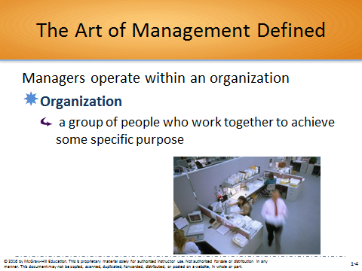

More formally, ***management*** is defined as (1) the pursuit of organizational goals *efficiently* and *effectively* by (2) integrating the work of people through (3) planning, organizing, leading, and controlling the organization’s resources.

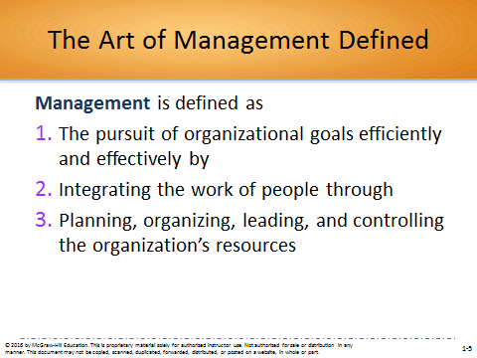

To be ***efficient*** means to use resources—people, money, raw materials, and the like—wisely and cost-effectively.

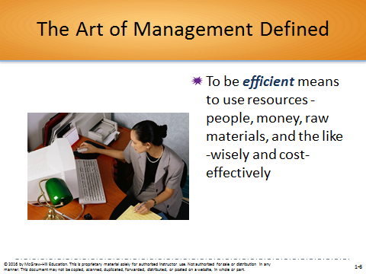

To be ***effective*** means to achieve results, to make the right decisions and successfully carry them out so that they achieve the organization’s goals.

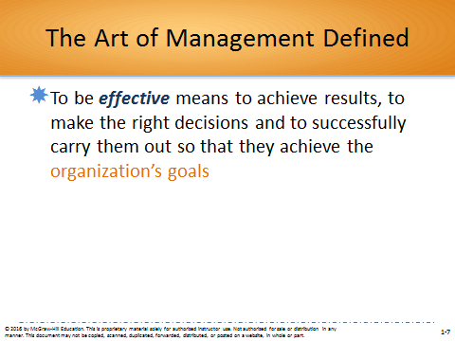

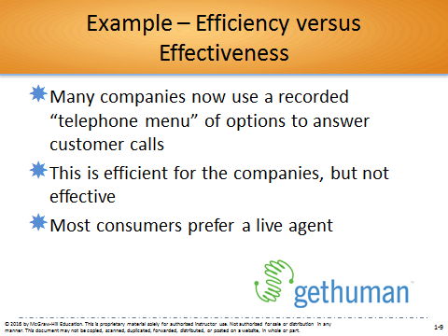

|  |
| --- |
| **Interactive Classroom Material:**  **EXAMPLE: Efficiency versus Effectiveness: “Don’t Tell Me You’re Sorry, Just Fix the Problem!” (p. 5-6)**  This Example describes customer service, or lack of it, in the airline industry. Many airlines favor efficiency over effectiveness, but this costs airlines’ bottom line as they cannot retain customers. Apologies do not help either when deemed half-hearted or insincere as customers want their problems fixed, not just talk.  **YOUR CALL**  **What recent unpleasant customer experience would you want to post on this website?**  *Students should share unpleasant travel experiences with different airlines. Are these experiences related to an airline trying to be efficient over effective? What was the end result of this experience (i.e., will the student use this airline again?). Students can also discuss common responses, or excuses, they have heard from customer service agents at the airline. Did they feel as if these responses were half-hearted or insincere?*  **Additional Activities:**  One way to build on this Example is to have the students watch the video segment “Airfare Sale Crashes Southwest Airlines' Website.” This 3-minute video profiles how Southwest Airline’s website crashed in early June 2015 due to a spike in customer demand following the announcement of a fare sale. The video provides a way to illustrate how a company needs to strike a balance between efficiency and effectiveness when dealing with upset customers. Consider using the following discussion questions:  Critique Southwest’s handling of this situation.  Given that the firm’s website has previously crashed when the company announced fare sales, does that influence your perceptions of how the company addressed the situation?  What other recommendations would you make to the airline for responding to customer complaints about not being able to buy a sale ticket and/or use the online check-in feature when the website was down?  Video Link:  <http://abc13.com/travel/airfare-sale-crashes-southwest-airlines-website/768713/> |



2) What Are the Rewards of Studying and Practicing Management?

The payoffs of studying management as a discipline include:

a. You will understand how to deal with organizations from the outside, and how people on the inside make decisions.

1. You will understand how to relate to your supervisors.
2. You will understand how to interact with coworkers.
3. You will understand how to manage yourself in the workplace.

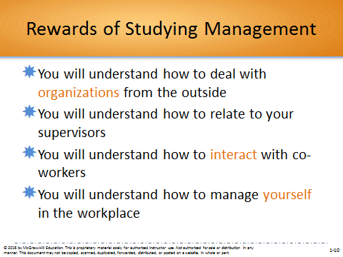

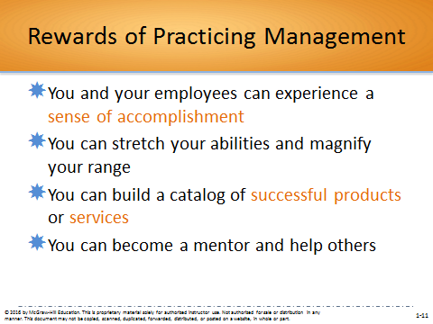

**1.2 What Managers Do: The Four Principal Functions Are (pp. 9 - 10)**

What would I actually do—that is, what would be my four principal functions—as a manager?

Section 1.2 defines the four functions of management: planning, organizing, leading and controlling. All these functions affect one another, are ongoing, and are performed simultaneously.

One way that you could begin your coverage of these topics is to have the students watch the video “*Target Manager Gives Rousing Black Friday Speech*.” In this 1-minute video, students can see Target manager Scott Simms give his employees a rousing motivational speech prior to the start of Black Friday shopping. The video is a fun way for students to consider their views of what a manager does. The video is currently available at: <http://abcnews.go.com/GMA/video/target-manager-rousing-black-friday-speech-27376638>.

**Possible Topics for Discussion:**

* Have the students arrange a time to interview their manager or someone who works in a managerial role. Have them ask the manager to describe how he or she spends a typical work week. Based on their interviews, have the students provide examples of how the person performs the four functions of management.
* Your professor could be considered the manager of your class. Discuss the ways that your professor performs the four management functions for your course.
* To what extent does Scott Simms of Target meet your image of what a manager does? Would you have found his pep talk to be motivating?

**Major Idea Outline:**

A. To achieve the goals of organization you perform the management process.

1. Managers perform the ***management process***, also known as the ***four******management functions***: *planning, organizing, leading,* and *controlling.*

2. All these functions affect each other, are ongoing, and are performed simultaneously.

B. *Planning* is defined as setting goals and deciding how to achieve them.

C. *Organizing* is defined as arranging tasks, people, and other resources to accomplish the work.

D. *Leading* is defined as motivating, directing, and otherwise influencing people to work hard to achieve the organization’s goals.

E. *Controlling* is defined as monitoring performance, comparing it with goals, and taking corrective action as needed.

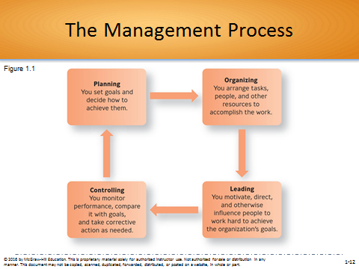

**1.3 Seven Challenges to Being an Exceptional Manager**

**(pp. 11 - 17)**

Challenges can make one feel alive. What are seven challenges I could look forward to as a manager?

Section 1.3 highlights the seven challenges facing any manager. Managers need to manage for competitive advantage—to stay ahead of rivals. They need to manage for diversity in race, ethnicity, gender, and so on, because the future won’t resemble the past. Managers also need to manage for the effects of globalization and of information technology, as well as always needing to manage to maintain ethical standards. Moreover, they need to manage for sustainability—to practice sound environmental policies. Finally, managers need to manage for the achievement of their own happiness and life goals.

One way that you could begin your coverage of these topics is to have the students read the *Fortune* article “Target Has a New CEO: Will He Re-Energize the Retailer?” This article profiles the strategic challenges facing the retailer and is a great illustration of the various challenges that managers face.

Article Citation:

Wahba, P. (2015). Target has a new CEO: Will he re-energize the retailer? *Fortune*, *171*(3), 86-94.

ProQuest Document ID: 1661345742

<http://fortune.com/target-new-ceo/>

**Possible Topics for Discussion:**

* Describe the most important challenges facing managers at your company (or a previous employer).
* Thinking of the industry in which you want to work after graduation, discuss how social media and big data are likely to impact this industry over the next decade.
* Provide specific recommendations for the CEO of Target on how the firm can best address the management challenges he is facing.

**Major Idea Outline:**

A. Managers face several challenges.

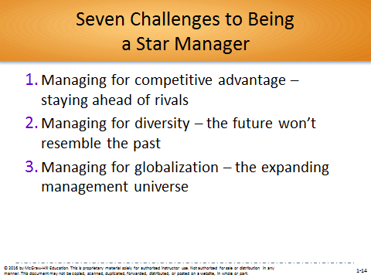

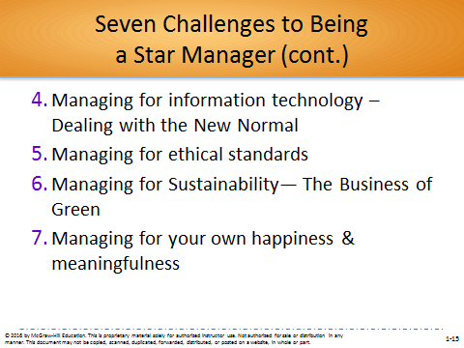

|  |
| --- |
| **Interactive Classroom Material:**  **EXAMPLE: The Struggle for Competitive Advantage: App-Based Ride-Share Services Leave the Taxi Industry Reeling (p. 11-12)**  Smartphones and apps have led to the rise of ride-sharing companies like Uber, Lyft and Sidecar, challenging the traditional taxi cab industry. Cab companies are having trouble filling shifts, and many disabled riders are having trouble finding cabs with accommodations since ride-sharing companies do not have to follow government regulations mandating them like cabs do.  **YOUR CALL**  **Which sector do you think will prevail?**  *This Example shows typical challenges managers in the cab industry are facing. This includes information technology issues, as well as managing for competitive advantage. Ride-sharing firms are so far more flexible and unregulated, allowing them a true competitive advantage.*  *Students can share their experiences with ride-sharing firms, such as Uber, and provide the pros and cons for such a service.*  **Additional Activities:**  One way to build on this Example is to have the students read the *Huffington Post* article “Meet 'The Rideshare Guy' (He Works for Uber, Lyft and Sidecar).” This article provides insights into what it might be like for students considering supplementing their income by working for a ride-sharing company. Consider using the following discussion questions:  From a passenger perspective, describe the advantages and disadvantages of using a traditional taxi cab versus ride-sharing companies for your transportation needs.  From an employee perspective, describe the advantages and disadvantages of being a driver for a traditional taxi cab versus a ride-sharing company.  Assume you have been hired as a political lobbyist to convince governmental regulators in your state from imposing regulatory restrictions on ride-sharing companies. How could you argue to governmental officials that it is best to limit the number of restrictions faced by these types of companies?  Article Link:  <http://www.huffingtonpost.com/dieter-holger/meet-the-rideshare-guy-he_b_6557986.html> |

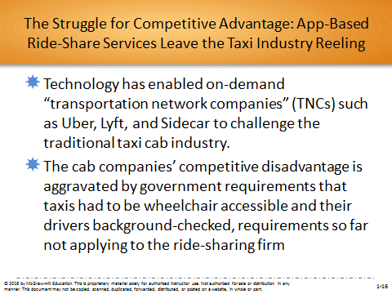

B. Challenge #1: Managing for Competitive Advantage—Staying Ahead of Rivals

1. ***Competitive advantage*** is the ability of an organization to produce goods or services more effectively than its competitors do, thereby outperforming them in four areas:

a. Being responsive to customers*:* The first law of business is, *take care of the customer.*

b. Innovation: Finding ways to deliver new or better goods or services is called ***innovation.***

c. Quality: Making improvements in quality has become an important management idea.

d*.* Efficiency*:* Companies try to produce goods or services using as few employees (and raw materials) as possible.

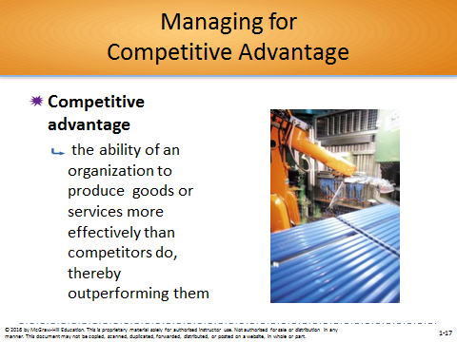

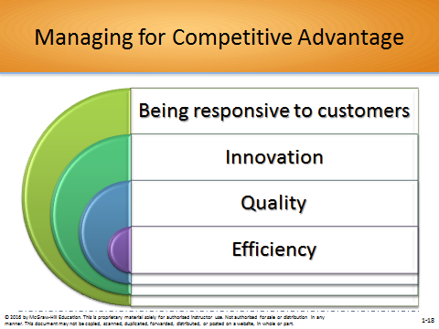

C. Challenge #2: Managing for Diversity —The Future Won’t Resemble the Past

1. During the next half-century, the mix of American racial or ethnic groups will change considerably, becoming more diverse.

2. The challenge to the manager is to maximize the contributions of these diverse employees.

D. Challenge #3: Managing for Globalization — The Expanding Management Universe

1. Not understanding cultural differences can affect how well organizations manage globally.

2. American firms are doing more business globally, and global firms are coming to the U.S.

3. Managing for globalization will be a complex, ongoing challenge.

**(Correct answer is B)**

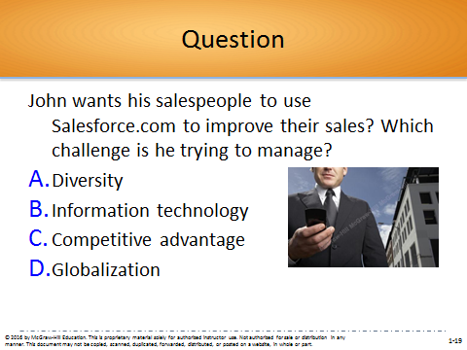

E. Challenge #4: Managing for Information Technology

1. The ***Internet*** is the global network of independently operating but interconnected computers, linking hundreds of thousands of smaller networks around the world.

2. ***E-commerce***, or ***electronic commerce –*** the buying and selling of services over computer networks – is reshaping industries.

3. Information technology has made possible ***e-business***, using the Internet to facilitate every aspect of running a business.

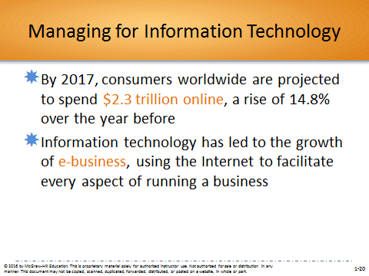

4. Implications of e-business: 21st-century managers need to understand and use:

a. Far-ranging e-management and e-communication, including:

(1) ***E-mail***, or text messages and documents transmitted over a computer network.

(2) ***Project management software***—programs for planning and scheduling the people, costs, and resources to complete a project on time.

b. Accelerated decision making, conflict, and stress

(1) The Internet connects us to huge, interconnected ***databases***—computerized collections of interrelated files.

(2) The pace and quality of management are affected, increasing stress and conflict.

c. Changes in organizational structure, jobs, goal setting, and knowledge management

(1) Organizations and teams have become “virtual”; they are no longer bound by time zones and locations.

(2) Employees may ***telecommute***, or work from home or remote locations using a variety of information technologies.

(3) Meetings may be conducted via ***videoconferencing***, using video and audio links along with computers to let people in different locations see, hear, and talk with one another.

(4) ***Collaborative computing***, using state-of-the-art computer software and hardware, will help people work better together.

(5) Managers and employees will need to be much more flexible, through ***knowledge management*** — the implementation of systems and practices to increase the sharing of knowledge and information throughout an organization.

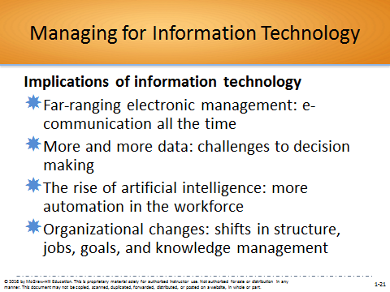

F. Challenge #5: Managing for Ethical Standards

1. With the pressure to meet sales targets, managers can face ethical dilemmas.

|  |
| --- |
| **Interactive Classroom Material:**  **PRACTICAL ACTION: Preparing Yourself to Behave Right When You’re Tempted to Cheat (p. 16)**  This Example shows that there are all kinds of reasons why people cheat. How we think we may act when put in the position to cheat, and how we actually act, may be very different. There is now research attempting to understand the underlying reasons people act the way they do when it comes to unethical behavior, and how to nudge them toward the right behavior. Moreover, sometimes we see something wrong occur, can’t figure out how to address it, and end up justifying it as okay.  **YOUR CALL**  **Can you tell yourself how you should—and must—behave the next time you’re tempted to cheat or see someone cheating?**  *When it comes to seeing others cheating, it begins with knowing when you probably will not speak up. Once you figure this out, you need to be courageous and take action as you have already anticipated the situation and come up with a plan. When it comes to your own temptation to cheat, there is a need to learn “how to be ethical” in the workplace and in life. Students should discuss the ways they can nudge themselves into the right behavior. Fear of punishment, the desire to do good, etc. are good ways to start on this.*  **Additional Activities:**  One way that you could build on this Practical Action is to have the students read the *Wall Street Journal* article “Cheating Concerns in Asia Cloud SAT Testing.” The article discusses how it is becoming easier than ever for students to game the system when taking the SAT college-entrance exam. Consider using the following discussion questions:  What actions should academic institutions take to deal with the fact that cheating occurs in the SAT testing process?  If you knew that you could have cheated on the SAT exam to dramatically increase your score without getting caught, would you have done it? Explain your position.  Assume that you just learned that one of your friends has been cheating on exams but has never been caught by his or her professors. Would you report your friend using your institution’s academic integrity reporting system? Explain your position.  Article Citation:  Te-Ping, C., & Schultz, A. (2015, June 6). Cheating concerns in Asia cloud SAT testing. *Wall Street Journal Online*.  ProQuest Document ID: 1686128955  <http://www.wsj.com/articles/cheating-concerns-in-asia-cloud-sat-testing-1433549895> |

G. Challenge #6: Managing for Sustainability – The Business of Green

1. ***Sustainability*** is defined as economic development that meets the needs of the present without compromising the ability of future generations to meet their own needs.

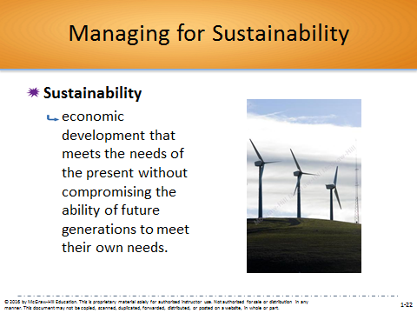

H. Challenge #7: Managing for Your Own Happiness and Life Goals

1. Not everyone finds being a manager fulfilling.

2. Others feel that management is a great job if you truly like people and enjoy mentoring.

|  |
| --- |
| **SELF-ASSESSMENT 1.1 (p. 17)**  **How Strong Is My Motivation to Be a Manager?**  Go to connect.mheducation.com and take Self-Assessment 1.1.  **Student Questions:**   1. Does this instrument accurately assess your potential as a manager?   *Student responses here will differ, however all students should have a better understanding of the components of management.*   1. Which of the seven dimensions do you think is likely the best predictor of managerial success? Which is the least? Explain.   *Student responses will differ here. Some will respond with information technology if they think that is the direction we are going in today’s world. Others may be more ethics or diversity related. Overall, the strongest response may be managing for a competitive advantage as it can include all the above. There really would not be a least predictor of managerial success, but students can have their own opinions here.*   1. The instrument emphasizes competition with others in a win–lose mentality. Describe the pros and cons of this approach to management.   *Students will hopefully point out pros as being success as a byproduct of wanting to win and succeed and overcome challenges, but a big con would be the whole “win-lose” thought process. Students should identify that “win-win” mentalities work out well in negotiations and daily operations.*  **Additional Activities:**  You can also consult the Connect Instructors Manual for the post-assessment activity and corresponding PowerPoint slides used for this Self-Assessment in Connect. In this activity, students should be assigned to groups based on their Self-Assessment scores. Students with high motivation to lead should be grouped together and students with a low motivation to lead should also be grouped together. Students who scored highly should discuss what they do at work to exhibit their motivation to lead. Students who scored low should discuss what they can do at work to increase their motivation to lead. Both groups should present to the class as a whole. You can lead discussion and point out how students can increase their motivation to lead. |

**1.4 Pyramid Power: Levels & Areas of Management**

**(pp. 18 - 21)**

What are the levels and areas of management I need to know to move up, down, and sideways?

Section 1.4 defines the four levels of managers: top, middle, first line and team leaders. There are two areas of management as well: general and functional managers. Managers may work for for-profit, nonprofit, or mutual-benefit organizations.

One way that you could begin your coverage of these topics is to have the students read the *Wall Street Journal* article “Starting Pay for a Wal-Mart Manager: $10.90.” This article profiles the various managerial levels at the world’s largest retailer. The article is available to wsj.com subscribers at: <http://www.wsj.com/articles/wal-mart-to-raise-wages-for-some-store-department-managers-1433252916>

Article Citation:

Nassauer, S. (2015, June 2). Starting pay for a Wal-Mart manager: $10.90. *Wall Street Journal Online*.

ProQuest Document ID: 1684991777

**Possible Topics for Discussion:**

* Describe the typical duties of the top managers, the middle managers, the first-line managers and the team leaders at your employer (or a previous one).
* Discuss how the seven challenges to being an exceptional manager described in Section 1.3 might be different for managers of for-profit, nonprofit and mutual-benefit organizations.
* Using the *Wall Street Journal* article “Starting Pay for a Wal-Mart Manager: $10.90” as your foundation, describe the organizational changes occurring at Wal-Mart and the strategic reasons for those changes.

**Major Idea Outline:**

A. Role of Management

1. Peter Drucker’s organization model sees the manager as a conductor whose role is not to play each instrument but to lead all the musicians through the most effective performance.

2. This model contrasts with the traditional pyramid organizational model.

B. The Traditional Management Pyramid: Levels and Areas

1. All kinds of organizations can be illustrated using a pyramid from top managers to non-managerial personnel.

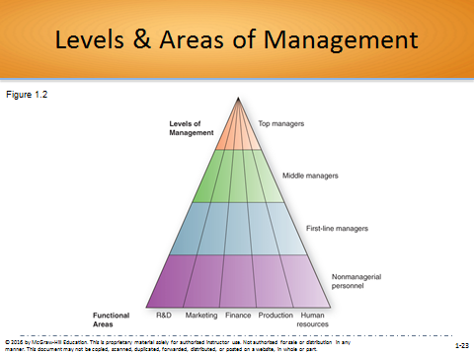

1. Three Levels of Management
2. Top Managers: Determining Overall Direction

a. ***Top managers*** have titles like “chief executive officer (CEO),” “chief operating officer (COO),” and “president.”

b. Top managers make long-term decisions about the overall direction of the organization and establish the objectives, policies, and strategies for it.

c. These executives must be future oriented, dealing with uncertain, highly competitive conditions.

d. These managers are at the summit of the management pyramid.

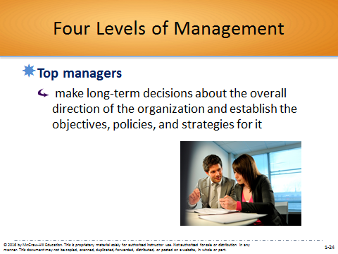

2. Middle Managers: Implementing Policies and Plans

a. ***Middle managers*** implement the policies and plans of the top managers above them and supervise and coordinate the activities of the first-line managers below them.

b. Titles may be “clinic director,” “dean of students,” “division head,” or “plant manager.”

3. First-Line Managers: Directing Daily Tasks

a. Examples of job titles at the bottom of the pyramid: “departmental head,” “foreman,” “team leader,” or “supervisor.”

b. *Supervisor* is the name often given to first-line managers as a whole.

1. ***First-line managers*** make short-term operating decisions, directing the daily tasks of nonmanagerial personnel.

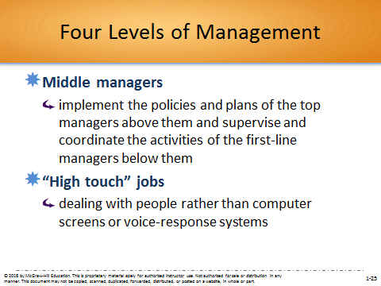

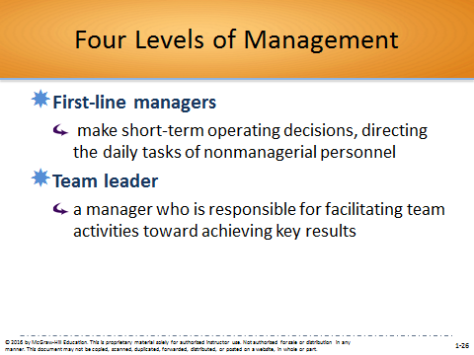

|  |
| --- |
| **Group Exercise:** How Well Do Managers Manage Their Time?  There is a group exercise available at the end of this manual that allows students to apply top management level time management.  **Exercise Objectives**   * To see how time is allocated in a top management position. * To start to think about how you might spend your time in a top management position. * To see what you think about this kind of job and what functions are performed. |

D. Areas of Management: Functional Managers versus General Managers

1. The organization is run by 2 types of managers—functional and general.

2. Functional Managers: Responsible for One Activity

a. Titles of functional managers may be “vice president of production,” “director of finance,” or “administrator for human resources.”

b. A ***functional manager*** is responsible for just one organizational activity.

3. General Managers: Responsible for Several Activities

a. An executive vice president over several departments is a general manager.

b. A ***general manager*** is responsible for several organizational activities.

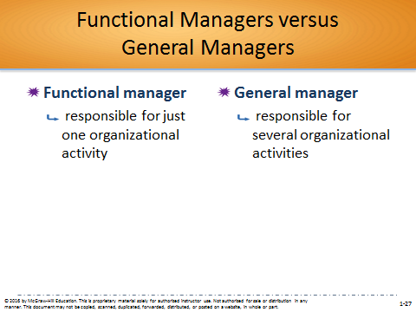

(Correct answer is C)

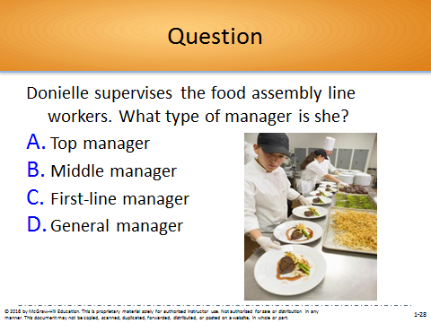

E. Managers for Three Types of Organizations: For-Profit, Nonprofit, Mutual-Benefit

1. Organizations are classified according to the purposes for which they are formed.

a. *For-profit organizations:* for making money.

b. *Nonprofit organizations:* for offering services.

(1) Their purpose is to offer services to some clients, not to make a profit.

1. *Commonweal organizations* offer services to all clients within their jurisdictions.

c. *Mutual-benefit organizations:* for aiding members.

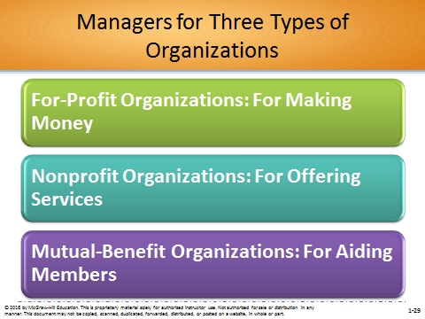

**1.5 The Skills Exceptional Managers Need (pp. 22 - 23)**

To be a terrific manager, what skills should I cultivate?

Section 1.5 highlights three principal skills good managers need. The first is technical, the ability to perform a specific job. The second is conceptual, the ability to think analytically. The third is human, the ability to interact well with people.

One way that you could begin your coverage of these topics is to have the students watch the TechCrunch video “*Inside Jobs: The Facilities Manager Who’s Been Google, Facebook and Now Flipboard’s Secret Weapon*.” In this 8-minute video, Scott Oligher, head of facilities at Flipboard, describes the skills needed to perform his job responsibilities. The video is currently available at: <http://techcrunch.com/2014/06/23/inside-jobs-facilities-manager-tech-company-flipboard/>.

**Possible Topics for Discussion:**

* Provide examples of how you have been able to enhance the skills needed to be an exceptional manager through your coursework.
* Assume that you wanted to improve your human skills. Discuss actions that you could take to further develop these skills.
* Describe examples of the technical, conceptual and human skills that facilities managers such as Scott Oligher need while performing their jobs.

**Major Idea Outline:**

Researcher Robert Katz found that managers acquire three principal skills:

A. Technical Skills – The Ability to Perform a Specific Job

1. ***Technical skills*** consist of the job-specific knowledge needed to perform well in a specialized field.

2. Having technical skills seems to be most important at the lower levels of management.

B. Conceptual Skills – The Ability to Think Analytically

1. ***Conceptual skills*** consist of the ability to think analytically, to visualize an organization as a whole, and understand how the parts work together.

2. Conceptual skills are particularly important for top managers.

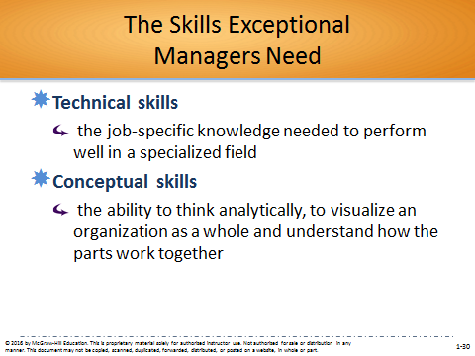

C. Human Skills – The Ability to Interact Well with People

1. ***Human skills*** consist of the ability to work well in cooperation with other people in order to get things done.

1. These skills are necessary for managers of all levels.
2. Developing these skills may be an ongoing, lifelong effort.

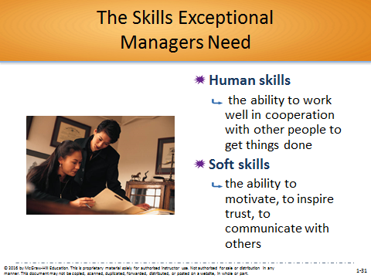

D. The Most Valued Traits in Managers – Among the chief skills companies seek in top managers are the following:

1. The ability to motivate and engage others.
2. The ability to communicate.
3. Work experience outside the United States.

4. High energy levels to meet the demands of global travel and a 24/7 world.

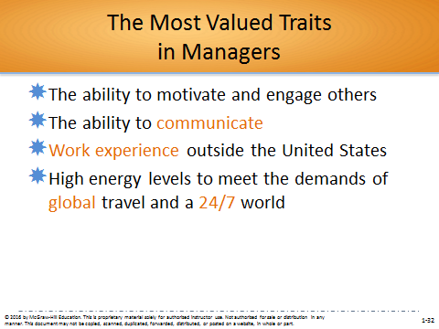

**1.6 Roles Managers Must Play Successfully (pp. 24 - 27)**

To be an exceptional manager, what roles must I play successfully?

Section 1.6 discusses the three roles manager play: interpersonal, informational and decisional. Interpersonal roles include figurehead, leader, and liaison activities. Informational roles are monitor, disseminator, and spokesperson. Decisional roles are entrepreneur, disturbance handler, resource allocator, and negotiator.

One way that you could begin your coverage of these topics is to have the students read the *Forbes* article “Twinkie's Miracle Comeback.” This article can be used to highlight the various managerial roles that helped to save one of the country’s most iconic products.

Article Citation:

Bertoni, S. (2015, May 4). Twinkie's miracle comeback: The untold, inside story of a $2 billion feast. *Forbes*.

ProQuest Document ID: 1679729744

<http://www.forbes.com/sites/stevenbertoni/2015/04/15/twinkie-billion-dollar-comeback-hostess-metropoulos-apollo-jhawar/>

**Possible Topics for Discussion:**

* Describe ways that technology and social media have changed the roles of managers since Mintzberg’s classic study in the 1960s.
* Given the textbook’s description of the roles that managers must play successfully, does a managerial career sound interesting to you? Explain your position.
* Using the article “*Twinkie’s Miracle Comeback*” as your foundation, provide examples of the managerial roles and management skills that helped to save Twinkies.

**Major Idea Outline:**

A. The Manager’s Roles: Mintzberg’s Useful Findings

1. Scholar Henry Mintzberg shadowed managers in the 1960s to see what they do; he noted three findings.

a. *A manager relies more on verbal than on written communication.*

(1) Most managers back then tended to get information through phone conversations and meetings.

(2) E-mail makes it possible to communicate almost as rapidly in writing as with the spoken word.

b. *A manager works long hours at an intense pace.*

(1) Long hours at work, typically 50 hours per week, are standard.

(2) Other studies found even longer work weeks.

(3) However, more companies are allowing manager to reduce their working hours and spend more time with their families.

c. *A manager’s work is characterized by fragmentation, brevity, and variety.*

(1) Only about 1/10th of managerial activity took more than an hour.

(2) The executive’s work time has been characterized as “the interrupt-driven day.”

(3) Mintzberg found that time and task management is a major challenge for every manager.

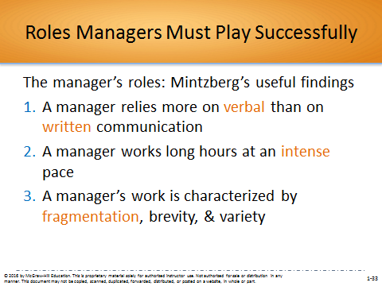

|  |
| --- |
| **Interactive Classroom Material:**  **PRACTICAL ACTION: Executive Functioning: How Good Are You at Focusing Your Thoughts, Controlling Your Impulses, & Avoiding Distractions? (pp. 25-26)**  This Example focuses on managing yourself and your resources in the workplace. Gen Z students are used to multitasking by using their smartphones to do multiple things at one time and still trying to pay attention in class. However, this leads to poor learning and can affect executive functioning in the future. To be successful not only in school but in the workplace—especially as a manager—students need to learn to direct their attention. This is known as focus or mindfulness.  **YOUR CALL**  **Is this a problem for you? What can you do to improve your “executive functioning”?**  *This Example demonstrates why it is important for students to direct their attention on one task at a time. Multitasking may be important, at times, but does not mean that your brain should consistently be processing multiple tasks on a continuous basis. This could lead to poor decision making and lack of attention, not to mention procrastination. Students who find procrastination is a problem should try to limit diversions, especially electronic ones.*  **Additional Activities:**  One way that you could build on this Practical Action is to have the students watch the video “Are Smartphones Making Us Stupid?” This 2-minute video profiles the results of recent studies from the University of Waterloo that suggest that smartphone use can lead to lazy thinking. The video is currently available at: <http://www.valleynewslive.com/home/headlines/Research-Finds-Your-Smartphone-Might-Make-You-Stupid-295899401.html>. Consider using the following discussion questions:  Discuss the downsides when a manager only relies on his or her smartphone to search for information or to problem-solve.  Assume that your company has a policy that forbids cell phone use during work meetings, even if you are using the device to do work. Would you support such a policy? Defend your point of view.  Discuss how you could more effectively manage technology to make you a better manager. |



B. Three Types of Managerial Roles - Mintzberg concluded that managers play three broad types of roles or “organized sets of behavior.”

1. In their ***interpersonal roles***, managers interact with people inside and outside of their work units.

a. *Figurehead role*: performing symbolic tasks that represent your organization.

b. *Leader role:* being responsible for the actions of your subordinates.

c. *Liaison role*: working with other people outside your work unit and organization.

2. In their three ***informational roles –*** as monitor, disseminator, and spokesperson – managers receive and communicate information with other people inside and outside of the organization.

a. *Monitor role*: being constantly alert for useful information.

b. *Disseminator role*: giving important information to employees.

c. *Spokesperson role*: being a diplomat, putting the best face on the activities of the work unit or organization.

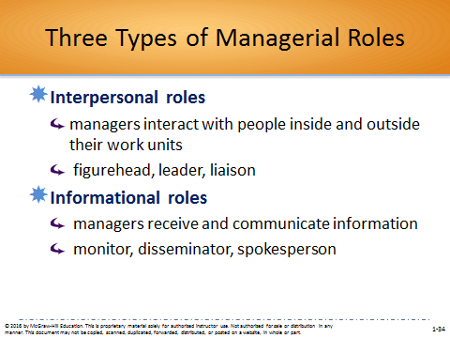

3. In their ***decisional roles***, managers use information to make decisions to solve problems or take advantage of opportunities.

a. *Entrepreneur role*: initiating and encouraging change and innovation.

b. *Disturbance handler role*: handling unforeseen problems.

c. *Resource allocator:* setting priorities about use of resources.

d. *Negotiator role*: working with others inside and outside the organization.

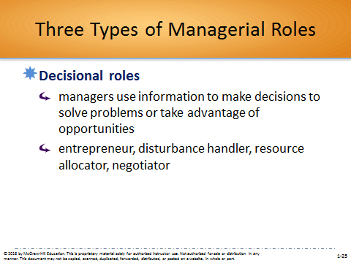

**(Correct answer is A)**

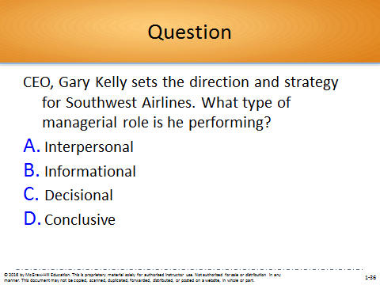

**1.7 The Link between Entrepreneurship & Management**

**(pp. 28 - 32)**

Do I have what it takes to be an entrepreneur?

Section 1.7 defines entrepreneurship and its subparts: the entrepreneur and the intrapreneur. Entrepreneurs and managers differ in many ways, and may have different characteristics.

One way that you could begin your coverage of these topics is to have the students watch the video “It's Never Too Late to be a Late Bloomer” from the CBS news program *Sunday Morning*. This 7-minute video profiles individuals who did not become entrepreneurs until later in life, which may counter stereotypes that your students may have that entrepreneurs are always young. The video is currently available at: <http://www.cbsnews.com/news/its-never-too-late-to-be-a-late-bloomer/>

**Possible Topics for Discussion:**

* Who do you think makes the best entrepreneurs, so-called necessity entrepreneurs or opportunity entrepreneurs? Defend your point of view.
* Compare and contrast the advantages and disadvantages of being an entrepreneur versus an intrapreneur.
* Does a person’s age help or hinder their ability to be a successful entrepreneur? Defend your point of view.

|  |
| --- |
| **Interactive Classroom Material:**  **EXAMPLE: A Hot Start-Up Cleans Up: Homejoy Transforms an Old Business (pp. 28-29)**  This Example discusses Homejoy, a home cleaning service that charges a flat $20 an hour no matter how frequent cleanings are scheduled for. Homejoy certifies that its cleaners have gone through extensive background checks, and provides insurance. Cleaners can also select their own geographic locations and work hours, and clients can book, cancel and reschedule cleanings through their computers or smartphones. The organization also has a foundation meant to help the environment and those in need.  **YOUR CALL**  **Do you think you have the stomach for the risks involved in establishing and growing a start-up? What are some risks associated with owning your own business?**  *Owning your own business has tremendous risks and is not for the faint of heart. There are capital needs, as well as the requirement to be patient and stay the path, even when things may not be going your way. Students who score high on the entrepreneurial spirit Self-Assessment (Self-Assessment 1.2) may be more keen on starting their own business and better suited for the risks that come with such an endeavor.*  **Additional Activities:**  One way to build on this Example is to have the students watch the video “*How Homejoy Swept the Competition*.” In this video, Homejoy co-founder Adora Cheung discusses some of the steps taken to launch the firm. The entire video is 30 minutes, but the first 12 minutes provide particularly interesting comments. You could consider showing only the first-half of the video or assign the video for outside-of-class viewing if class time is a constraint. Consider using the following discussion questions:  Discuss the managerial skills of Adora Cheung that have contributed to the success of Homejoy.  Describe the psychological characteristics of entrepreneurs that you observed in Adora.  In the video, Adora addresses the need to have great cleaners. What recommendations would you give to the firm to find and retain great cleaners?  Video Link:  <https://www.youtube.com/watch?v=PqE2B-YzFuc> |



**Major Idea Outline:**

A. Entrepreneurship Defined: Taking Risks in Pursuit of Opportunity

1. *What entrepreneurship is*—***Entrepreneurship*** is the process of taking risks to try to create a new empire.

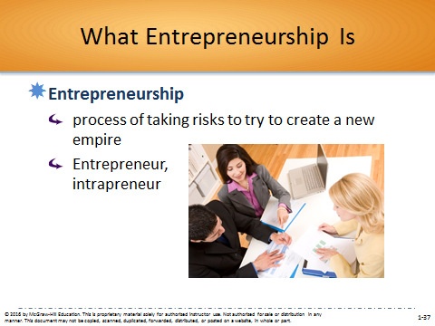

a. The ***entrepreneur*** is someone who sees a new opportunity for a product or service and launches a business to try to realize it.

b. An ***intrapreneur*** is someone who works inside an existing organization who sees an opportunity for a product or service and mobilizes the organization’s resources to try to realize it.

|  |
| --- |
| **Interactive Classroom Material:**  **EXAMPLE: Example of an Intrapreneur: Intel’s Anthropologist Genevieve Bell Explores Possible Innovations for Automakers (p. 30)**  This Example discusses how Intel hired an anthropologist to lead 100 social scientists and designers in order to find how people use technology in their homes and in public. Specifically, they have focused on technology and its use in automobiles. This has led Intel to join Jaguar Land Rover to find ways for consumers to better synchronize their personal devices with their cars.  **YOUR CALL**  **Do you think most companies truly support intrapreneurship? Why would they not?**  *Students should provide examples of companies that support intrapreneurship, and how they do that. Many companies have specific programs set up for this, but there are a handful of organizations that do not support intrapreneurship. This may be because of the capital investment required and/or the loss of productivity while engaging in such activities.*  **Additional Activities:**  One way to build on this Example is to have the students watch Bhavna Mathur’s TED Talk “*Unleashing Social Intrapreneur*.” In this 7-minute video, Bhavna profiles key differences between entrepreneurs and intrapreneurs. Consider using the following discussion questions:  Discuss how the challenges facing an intrapreneur working for a company like 3M or Google would be different than those facing a start-up entrepreneur.  Compare and contrast the skills and competencies needed for a successful intrapreneur versus an entrepreneur.  A social intrapreneur has been defined as someone who works to develop and promote practical solutions to social or environmental challenges inside a major organization. How might the characteristics of social intrapreneurs differ from entrepreneurs?  Video Link:  <https://www.youtube.com/watch?v=_WnUZZEgywQ> |



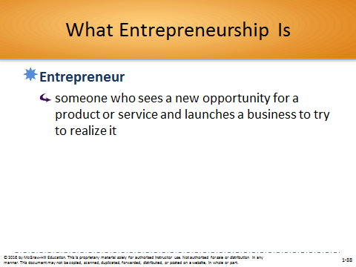

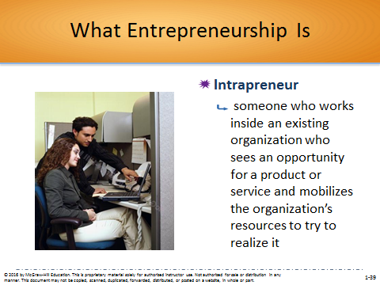

2. How do entrepreneurs and managers differ?

a. Being an entrepreneur is what it takes to *start* a business; being a manager is what it takes to *grow* or *maintain* a business.

b. Entrepreneurial companies have been called *“gazelles”* because they have two characteristics —speed and agility.

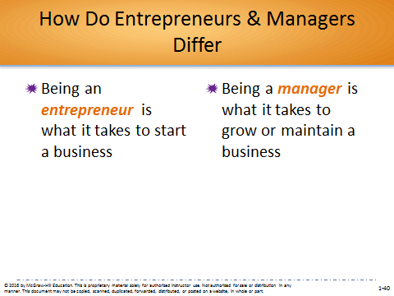

3. Entrepreneurs have psychological characteristics that are different from managers.

a. Characteristic of both — high need for achievement

(1) Entrepreneurs seem to be motivated to pursue moderately difficult goals in order to realize their ideas and financial rewards.

(2) Managers are more motivated by promotions and organizational rewards.

b. Characteristic of both — belief in personal control of destiny.

(1) An ***internal locus of control*** is the belief that you control your own destiny.

(2) Both entrepreneurs and managers like to think they have personal control over their lives.

1. Characteristic of both, but especially of entrepreneurs — high energy level and action orientation — entrepreneurs are especially apt to be impatient.
2. Characteristic of both, but especially entrepreneurs – high tolerance for ambiguity.
3. More characteristic of entrepreneurs than managers – self-confidence and tolerance for risk.

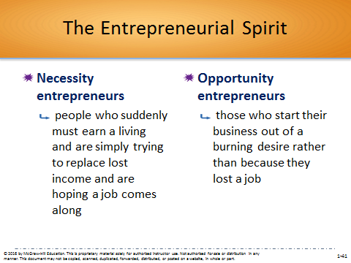

**(Correct answer is C)**

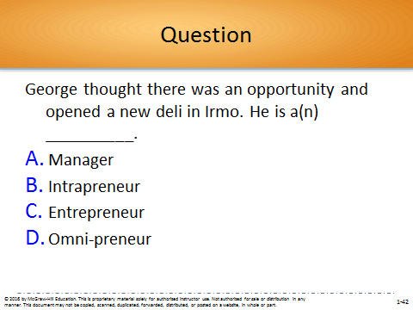

|  |
| --- |
| **SELF-ASSESSMENT 1.2 (p. 32)**  **To What Extent Do You Possess an Entrepreneurial Spirit?**  Go to connect.mheducation.com and take Self-Assessment 1.2.  **Student Questions:**   1. To what extent are your motives, aptitudes, and attitudes similar to entrepreneurs? Explain.   *Students who have high energy, internal locus of control, high tolerance for ambiguity and self-confidence would fare well. Patience and motivation, with the ability to overcome failure, are important as well. Student responses will differ, but should follow this theme.*   1. Based on your results, where do you have the biggest gaps with entrepreneurs in terms of the individual motives, aptitudes, and attitudes?   *The above answer should still hold true, but in the inverse.*   1. What do these gaps suggest about your entrepreneurial spirit? Discuss.   *Students should realize how they fare in their ability to have characteristics associated with entrepreneurs.*   1. Do these results encourage or discourage you from thinking about starting your own business? Explain.   *Student responses would differ based on how they interpret their own results and their desires to overcome results that may not fall in line with entrepreneurial efforts.*  **Additional Activities:**  You can also consult the Connect Instructors Manual for the post-assessment activity and corresponding PowerPoint slides used for this Self-Assessment in Connect. In this activity, students should be assigned to groups based on their Self-Assessment scores. Students with high and low scores should be mixed together. Groups should discuss how a high entrepreneurial orientation will assist organizations in being innovative and creative. Each group should create a short innovation policy for a mock organization. The policy should include resources and procedures for employees to exercise innovation and creativity while strengthening instinct and intuition. Each group should share their innovation policy with the class as a whole and solicit feedback. |

**CHALLENGE: MAJOR QUESTIONS**

**1.1 What are the rewards of being an exceptional manager?**

*An exceptional manager will be able to reach organizational goals efficiently. This means using resources wisely and cost-effectively (i.e., meeting budget). An exceptional manager will also be able to reach organizational goals effectively. This means integrating the work of people through the planning, organizing, leading and controlling. Moreover, good managers are fairly well compensated compared with most workers, and receive increased fringe benefits and status rewards as they go up the management hierarchy.*

**1.2 What would I actually do—that is, what would be my four principal functions—as a manager?**

*Think of the four principal functions of a manager as the abbreviation POLC. It starts with planning, or setting goals and deciding how to achieve them. Then there is organizing, or arranging tasks, people, and other resources to accomplish the work. There is also leading, which is motivating, directing, and otherwise influencing people to work hard to achieve the organization’s goals. Lastly, there is controlling, which is monitoring performance, comparing it with goals, and taking corrective action as needed.*

**1.3 Challenges can make one feel alive. What are seven challenges I could look forward to as a manager?**

*The seven challenges are as follows: 1)* *Managing for competitive advantage, which means an organization must stay ahead in four areas—being responsive to customers, innovating new products or services offering better quality, being more efficient; 2)* *Managing for diversity among different genders, ages, races, and ethnicities; 3)* *Managing for globalization, the expanding universe; 4) Managing for computers and telecommunications—information technology; 5)* *Managing for right and wrong, or ethical standards; 6) Managing for sustainability; and 7)* *Managing for your own happiness and meaningful life goals.*

**1.4 What are the levels and areas of management I need to know to move up, down, and sideways?**

*There are four management levels. Top managers make long-term decisions about the overall direction of the organization and establish the objectives, policies, and strategies for it. Middle managers implement the policies and plans of their superiors and supervise and coordinate the activities of the managers below them. First-line managers make short-term operating decisions, directing the daily tasks of non-managerial personnel.*

**1.5 To be a terrific manager, what skills should I cultivate?**

*The three skills that exceptional managers cultivate are technical, conceptual, and human. Technical skills consist of job-specific knowledge needed to perform well in a specialized field. Conceptual skills consist of the ability to think analytically, to visualize an organization as a whole, and to understand how the parts work together. Human skills consist of the ability to work well in cooperation with other people in order to get things done.*

**1.6 To be an exceptional manager, what roles must I play successfully?**

*The Mintzberg study shows that, first, a manager relies more on verbal than on written communication; second, managers work long hours at an intense pace; and, third, a manager’s work is characterized by fragmentation, brevity, and variety. Mintzberg concluded that managers play three broad roles: (1) interpersonal—figurehead, leader, and liaison; (2) informational—monitor, disseminator, and spokesperson; and (3) decisional—entrepreneur, disturbance handler, resource allocator, and negotiator.*

**1.7 Do I have what it takes to be an entrepreneur?**

*The following characteristics have a positive correlation with entrepreneurship: 1) high need for achievement, 2)* *belief in personal control of destiny, 3) high energy level and action orientation, 4) high tolerance for ambiguity, and 5) self-confidence and tolerance for risk.*

**MANAGEMENT IN ACTION:**

**Target CEO Works to Regain Consumer Trust after the Company Was Hacked**

1. From a management perspective, do you think Target made any major mistakes? Explain.

*The first mistake can be attributed to Mr. Steinhafel releasing a number of affected customers that was much higher than what may have actually been the case. An argument can be made that releasing the highest possible number was a decision that carried more integrity, but a counterargument can be made that providing misinformation, that will most likely alarm the public, is bad for the organization.*

*Another mistake can be attributed to providing services, such as free credit monitoring, that cost the organization a lot of expense, to all customers, not just those affected by the data breach. An argument can be made that this was a public outreach attempt by the organization, but do the costs associated with this warrant that?*

1. Which of the four principal managerial functions were exhibited by CEO Greg Steinhafel?

*Steinhafel was exhibiting the leadership function. Leading is defined as motivating, directing, and otherwise influencing people to work hard to achieve the organization’s goals. Here, Steinhafel had to make tough decisions and motivate his followers to follow-through with those decisions. Followers were not only executives such as the CFO who was testifying on Capitol Hill, but also managers who are walking down hallways on their cell phones. He also assembled a situation room and twice-daily status meeting, all signs of trying to motivate and lead his team.*

1. Which of the seven managerial challenges discussed in this chapter is Target facing? How are they handling these challenges?

*A major challenge Target is facing is related to information technology. The breach was massive and required a lot of expense and investment in information technology to solve the problem and also prevent future issues for the organization. This includes new chip technology, marketing funding and forensic/data security expenses.*

*Another challenge is related to competitive advantage. Target must be responsive to customers, which means it has to invest in call centers and increased staff at locations, and it has to be innovative and invest in safer technology. The case points out that Target is moving in this direction, and is trying to handle this challenge as best as it can.*

*A last challenge is ethics-related. Disclosing an extremely high number of affected users, and creating significant expenses for the organization (i.e., credit monitoring for all customers), may not be the best decisions. This can lead to some even questioning the ethics behind such decisions.*

1. What is your evaluation of Steinhafel’s ability to effectively execute the three key managerial roles—interpersonal, informational, and decisional? Explain.

*Steinhafel is known for visiting locations and talking with the staff on site, which shows some interpersonal strength. When the data breach occurred, and at the behest of his marketing executives, he recorded a video speaking to the public. This is both interpersonal and informational, as he is providing information to stakeholders. Informational also includes his desire to provide the number of affected people, even if it is the highest end of the numbers. Decisional came into play when he had to make one difficult decision after another, such as releasing affected user numbers and also providing free credit monitoring to all customers. Whether the decisions were right or wrong, he executed by actually making the decision.*

1. If you were a consultant to Target, what advice would you give to senior management about handling a crisis like this? Discuss.

*Consultants should recommend Target continue balancing the interests of all its stakeholders, including employees, customers, shareholders and regulators. It is important to invest in the safest technology, especially when you are handling the sensitive information of millions of people worldwide. It is also important to provide the best available information, and to expend company resources wisely. Though Target executives tried to handle this crisis as best as possible, there are still significant areas of improvement needed in case this type of crisis happens again.*

**LEGAL/ETHICAL CHALLENGE**

.

**To Delay or Not to Delay?**

You have been hired by a Vice President to create an employee attitude survey and gather results from all employees. Your presentation, complete with strengths and weaknesses, is ready to present. At the last minute the Vice President tells you that her boss’s boss has come to the presentation unannounced, and she believes that he will use the negative information to have her replaced. She asks that you delay your presentation.

**What would you do?**

1. *Deliver the presentation as planned.* A key decision here is how to balance loyalty and integrity. You were hired to prepare a warts-and-all report—to discover the true state of employee attitudes. Your report presents these facts accurately. As a result of your presentation, the company will better know how to motivate its employees. Presenting it, unvarnished, is the most honest thing you could do. However, you trust and respect the Vice President who hired you, and she could be damaged as a result of your report. If you choose this option, you must consider its consequences—to the Vice President and to yourself. If you present the true report, your own employment may be jeopardized.
2. *Give the presentation but skip over the negative results*. Delivering a sanitized report may spare your Vice President from negative consequences. May spare. It is possible that her fate has already been sealed. If your report doesn’t supply the ammunition, the boss’s boss will find something else that does. Also consider the consequences to your reputation of presenting an edited presentation. You were hired to evaluate the overall state of employees’ attitudes. If your report is less than honest, the Vice President, and any other managers who know your assignment, will know you fudged the results for political reasons.
3. *Go back to the meeting room and announce that your spouse has had an accident at home and you must leave immediately. You tell the group that you just received this message and that you will contact the Vice President to schedule a new meeting.* This option represents a lie. It would show loyalty to the Vice President, but it would clearly jeopardize your integrity if the truth came out.
4. *Invent other options. Discuss.*  Some students may see significant shades of grey instead of black-and-white “positive” or “negative” choices. If you go ahead with the presentation, giving honest evaluations, can you describe “problem areas” in softer terms? Or present employee responses by limiting your interpretation to quantitative results, minimizing subjective judgment? Stretch out the presentation over two sessions—basic data at one, interpretation in the next? The boss’s boss may not be able to stick around for an extended report. Perhaps let the Vice President herself present the strengths and weaknesses, enabling her to appear as the agent of change. People are very creative—you’ll probably get lots of other student suggestions. If there are older nontraditional students in your class (who have experience in real world business), it would be interesting to see how their choices differ from younger students’.

**GROUP EXERCISE: How Well Do Managers Manage Their Time?**

**Objectives**

• To see how time is allocated in a top management position.

• To start to think about how you might spend your time in a top management position.

• To see what you think about this kind of job and what functions are performed.

**Introduction**

Managers must allocate their time appropriately. If as a manager you continuously misallocate your time in terms of work coordination, your company will not reach its goals or, at the very least, you will not achieve your own goals and may become a liability to the organization. So, you must understand how to allocate your time wisely.

**Instructions**

The following is from Charles Handy’s *Understanding Organizations:*

*A senior manager’s diary:* One senior division manager sat down to review what he regarded as the major responsibilities of his job. He listed six key areas for himself:

1. Relations with head office: communicating with the top managers.
2. Long-term and strategic planning: the plans that position the company over time.
3. Operational responsibilities for particular ongoing activities: the day-to-day activities of the company.
4. Co-coordinating function: working with other parts of the company to complete a task or tasks.
5. Standard setting, performance, morale priorities: setting up quality standards and other types of standards, operationalizing performance appraisals, and developing a climate where employees want to work.
6. External relations: working with customers, watching what competitors are doing, dealing with pressure groups, working with suppliers.

As a group, estimate in percentages how you think this senior manager allocated his time to these six key areas. (The senior manager’s percentages are included at the end of this exercise.)

1. % 4. %

2. % 5. %

3. % 6. %

What areas would you add to his list? Why?

**Questions for Discussion**

1. How do your percentages compare to the senior division manager’s time allocation?
2. Why do you think that 1, 3, and 4 take so much of his time?
3. In this changing world do you think that more time should be spent on 2, 5, and 6?
4. How do managers “know” how to allocate their time? In his position, would you allocate your time differently? Why or why not?

**Answers**

After outlining the six key areas of responsibility in his job, the division manager then analyzed his diary for the previous 3 months and came up with the following approximate percentages of time spent on each of the key areas:

1. 20% 4. 25%

2. 10% 5. 5%

3. 35% 6. 5%

Adapted and modified by Anne Cowden, PhD, from Charles Handy’s *Understanding Organizations* (New York: Penguin, 1993), p. 338.

**MANAGER’S HOT SEAT**

Students may complete the “*Office Romance: Groping for Answers*” Manager’s Hot Seat exercises in Connect for this chapter.

**I. Introduction**

The scenario portrayed in this video segment highlights important and realistic challenges faced by managers. This case may be effectively used in a management or organizational behavior course to illustrate problem solving and decision making concepts, interpersonal communication processes, or conflict management. For a course in Human Resource Management, this scenario provides a rich background to discuss the potential risk of sexual harassment and the roles HR and managers need to play if faced with such a situation.

1. **Learning Objectives**
2. To assess students understanding of the analytical decision making approach and to apply it to a novel scenario.
3. To assess students’ ability to detect communication strengths and weaknesses.
4. To have students identify key issues related to inter-office romances and the legal and managerial implications, therein.

**III. Scenario Description:**

***Overview:***Abbe Willsby and Randall Keene are co-leaders of a 15-employee team in a retail/fashion company. Soon after Randall separated from his wife, the two began an affair… Six months later Abbe breaks off the relationship after hearing rumors that Randall still has an intimate relationship with his wife. She sends an email to the manager, Bill Schule, with complaints of sexual harassment and insists something be done. Abbe contends that her former boyfriend and co-leader is flirtatious, inappropriate and constantly discussing past intimate encounters they’d shared, while they work together. Prompted by the email sent by Abbe, Randall meets with the Manager asking for help with the situation.

***Profile:***

* Bill Schule has been working in a managerial capacity for over 22 years at various companies. Presently, Bill is a Senior Sales Executive at HypeTec, managing a sales force of 40 people. He has 15 teams, each led by a pair of highly experienced salespeople.
* Randall Keene has worked for HypeTec for 6 years and has been one of Bill’s team leaders for the past 3 years. Together, he and Abbe Wilsby have excelled at motivating and managing their team, raising the bar for all the sales teams within the department.

***References:*** The references included in the DVD are:

* Concepts in Decision Making (PPT 1-3)
* Six Steps in Decision Making (PPT 1-5)
* Components of Active Listening (PPT 1-8)
* The Communication Process (PPT 1-9)

***Back History:***Unbeknownst to Schule, Willsby and Keene had been engaged in a serious office romance for the past 6 months. Their romance had little effect on the office environment – the pair had gone from productive team leaders to productive team leaders in love, without any disruption……until the affair ended. A week of hostility and anger permeated the Willsby-Keene team, with a huge drop in productivity reported at the end of a 2-week period. Willsby had broken off the affair because Keene was still involved with the wife from whom he had supposedly separated.

Willsby was adamant that the breakup was not the problem – she was a professional woman and any woes of heartbreak or betrayal were not going to interrupt her performance in any way. The problem was that Keene was harassing her throughout the workday, with lots of sexual innuendo, reference to their past intimacies, sexually charged emails, and veiled threats that if she didn’t “go back to him”, he would have her tossed out of their department.

Willsby sends an email to Keene, cc-ing Schule, that annotates and lists the instances of harassment, excerpts from emails etc… She is insisting that Keene relocates to another team, or she will be filing a suit of sexual harassment against Keene and suit of a hostile environment against HypeTec.

***Scene Set-up:*** Keene receives the email before Schule and barges into his office.

***Scene Location:*** Schule’s office, HypeTec Wear; Tuesday morning 8.45am

***The Meeting - Summary***: Randall walks into Bill’s office unannounced clearly agitated over the email he just received from Abbe. Randall begins to explain the situation and Bill immediately expresses concern over the use of company email for personal matters. Randall acknowledges this concern but continues to plead his case by expressing that Abbe was being irrational and should be removed from the department.

Bill states that he wants to refrain from making any decisions until he has a private discussion with Abbe and talks things over with the Human Resources department. His primary motive is to ensure productivity of the team doesn’t suffer. He indicated strong disappointment with Randall for engaging in the office romance.

***Afterthoughts – Summary:*** Bill thinks that it is entirely possible to prevent litigation at this point. He plans to do some more investigation but believes that a solution can be agreed to by all parties. He reinforces his position that he needs to talk to Abbe and get the other side of the story and recommends that Randall not interact with Abbe at all until the situation gets resolved so that it doesn’t get worse. Bill does not feel that it was too soon to mention likely possible outcomes because they were outcomes typically outlined in organization’s policies (e.g., termination, transfer). Bill states that he feels that at a minimum the two leaders will be separated because they cannot continue to work together. Bill’s major concern with email is that it’s not secure and can be sent to many people and not be factual.

***Dossier:*** The specific artifacts included in the DVD are:

1. Willsby’s email (August)
2. Photograph showing Randall touching Abbe
3. Randall’s “threatening” email (July)

**IV. Discussion Questions:**

The *References* and related *Discussion Questions* may be found in PowerPoint slides 1-1 to 1-12.

*Learning Objective #1:* *To assess students understanding of the analytical decision making approach and to apply it to a novel scenario.*

1. Would this situation be an example of programmed or non-programmed decision making? Why? (PPT 1-2 &1-3)

Students’ responses will vary – focus should be on their thought process and justification rather than on which one they picked. It may depend on how often a manager has these situations. While this is probably not a frequent occurrence, the organization should have a lot of information to provide guidance on what to do. The employee handbook, dating policy, sexual harassment policy, etc. should help the manager and HR follow the appropriate steps.

However, the situation is unpredictable in that it is unclear if this can be resolved peacefully or if Abbe may pursue legal action. Therefore, both the manager and HR have to be very careful and thoughtful how they handle this situation and the solution they come up with.

1. What would be an example of a satisficing decision in this scenario? What consequences/benefits would this approach have? (PPT 1-2)

Students’ answers will vary. Any answer that is not mutually agreeable to HR, Abbe, Randall, and Bill could pose serious problems later. For example, a short term solution that minimizes disruption, may not fully address the problem which could arise again.

3. What is Bill’s greatest concern?

1. Productivity.
2. Liability.
3. Morale.

Bill seems to be most concerned about productivity and is downplaying the likelihood of a lawsuit. This may be an effective approach to not exacerbate the situation. However, the potential legal liabilities of Randall’s behavior should be made clear to him by either Bill or HR.

1. Assume you are Bill and you decide to use an analytical (or rational) decision making strategy to handle this situation (PPT 1-4 & 1-5). The analytical decision making approach involves the following steps:
2. Recognize need for decision
3. Define the problem
4. Generate alternatives
5. Evaluate alternatives
6. Implement a solution
7. Get feedback

Describe in detail the specific actions you would take for each step. Be sure to address the following questions in your answer:

1. Who would you talk to?
2. Where would you go for more information?
3. What relevant policies, procedures, laws are relevant here?

Students’ answers will vary. It is important that they carefully think through all the options after conducting some research and gathering information (e.g., company’s policies, legal implications). They should describe some process for getting feedback that the implemented solution is working so corrective action can be taken, if necessary.

*Note: The following “pop-up questions” may be found on PPT 1-6*

4.Bill’s first step should be:

1. Call Abbe.
2. Call HR.
3. Document Meeting.

Bill plans to call HR first for advice and then discuss the situation with Abbe. HR will probably coach Bill with regard to how to discuss the issue with Abbe. Since Bill manages Abbe, it seems wise to talk to her about the potential of continuing to work together or to make an alternative, mutually agreeable work arrangement. Soliciting her opinions will make her more likely to go along with the final decision.

5.Randall wants to hear Abbe’s side. Bill should:

1. Tell him.
2. Be confidential.
3. Meet as group.

Bill should not disclose information he receives from Abbe to Randall. At some point in the future, it might make sense to meet as a group, but currently, the individuals involved are probably too sensitive and emotional for it to be a productive group meeting.

6.Bill is discussing possible outcomes.

1. It’s too early
2. It’s appropriate
3. It’s HR’s job

Bill does not feel that it was too soon to mention likely possible outcomes because they were outcomes typically outlined in organization’s policies (e.g., termination, transfer). Because Bill is their manager, he should be the one to own the decision on the outcome. Having HR make the decision, may not be perceived to be in the Sales organizations’ best interest and may not be as accepted as it would be coming from Bill.

*Learning Objective #2:* *To assess students’ ability to detect communication strengths and weaknesses.*

1. Evaluate Bill and Randall’s active listening and communication skills (“Components of Active Listening” and “The Communication Process”; PPT 1-7 to 1-9). What did each do effectively? How could they have improved? Support your answers with the specific behaviors you observed.

Randall interrupted Bill frequently, indicating that he was not really listening to his point of view. Randall also would not accept the fact that there was another side to the story. Instead of listening, he spent time defending his position and thinking up arguments to refute Bill to ensure he got what he wanted.

Bill maintained his composure, was not flustered by Randall’s agitation. He empathized with Randall’s viewpoint without agreeing with it. While noting his dissatisfaction with what had happened, he withheld making a final evaluative judgment until more information was collected.

1.Randall’s agitated. What should Bill do?

* 1. Stop Meeting.
  2. Hear him out.
  3. Call Abbe in.

Discuss each option in terms of its relative effectiveness towards promoting supportive, professional communication. Option B: Hearing him out, while attempting to calm him down would prevent the situation from escalating. Options A and C may serve to create more disruption and tension between the parties.

1. Abbe and Randall chose to communicate about their personal relationship via email. What are the disadvantages of using this communication medium for this purpose? What would have been a more effective way for Abbe and Randall to communicate? (PPT 1-10)

Email should not have been used for personal business according to the company’s policy. This puts the company at risk if email of this nature was distributed to the general public.

Tone is hard to convey in emails so it is more likely to result in a miscommunication especially when dealing with a personal, emotional situation such as this.

A violation of company policy (office romance) is now documented and tangible evidence exists due to their communication via email.

Abbe and Randall probably would have had a more productive communication if they had met face to face so that body language, voice inflection and other non-verbal cues could have helped them interpret each other’s meaning better.

**⯑** 2.What is the concern about email use?

1. It’s not secure.
2. It’s not efficient.
3. Easy to misinterpret.

Bill’s major concern is that it is not secure and that the content could be misinterpreted because non-verbal cues are not present. He is also concerned that the email could be received outside of the organization and be damaging to the company’s image.

*Learning Objective #3:* *To have students identify key issues related to inter-office romances and the legal and managerial implications, therein.*

1. What guidance is HR likely to provide to Bill? What future actions are Bill’s responsibilities? What actions should HR take? (PPT 1-11)

HR should provide guidance in terms of the dating policy the organization has and the sexual harassment policy. Appropriate disciplinary action should be taken if it is written in a policy by Bill as their direct manager.

Bill definitely needs to talk to Abbe about her side of the story. Ask her what solution would be amenable to her that preserves the goals of the department. Convey that the interoffice relationship is not condoned and that it threatens the ability of the group to achieve their goals.

HR may want to interview Abbe and Randall to diffuse the situation and reinforce the importance of adhering to the organization’s sexual harassment and dating policy.

1. Abbe and Randall were co-leading a team. Does this situation pose the potential for a lawsuit based on quid pro quo or hostile work environment sexual harassment? Why? (PPT 1-11)

Because they did not have a supervisor/subordinate relationship in which one made employment-related decisions (e.g., firing, raises, promotions) that affected the other, this situation would more likely fall under the hostile environment theory of sexual harassment. Abbe would have to demonstrate that Randall’s actions created an abusive working environment. The fact that Abbe had been a willing participant in a prior relationship would make her case tougher to make.

1. Should the fact Abby and Randall were involved in a relationship be reflected on their performance evaluation? Who should be held accountable for the lower productivity of their team? (PPT 1-12)

If disciplinary actions were taken, it is probably not necessary to restate the specifics of the situation in the performance review. At that point, it is more important to focus on how effectively they have met their performance objectives. Therefore, if they are held accountable in their performance planning document for the team’s performance, then their performance evaluation should reflect the fact that the group’s performance declined (assuming the performance of the team didn’t rebound).